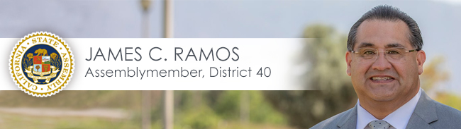

For Immediate Release Contact: Maria L. Lopez
March 13, 2020 916-312-9854 (Office); 916-712-9854 (Cell)

Ramos announces he will reschedule large group district events and encourages constituents to schedule telephone meetings rather than in-person meetings with his offices

SAN BERNARDINO—Assemblymember James C. Ramos (D-Highland) today announced that he is postponing or rescheduling district events and non-essential in person meetings in accordance with California Department of Public Health Guidelines. He stated:

Right now, serious health concerns must take priority for the public good. It is imperative that elected officials and others lead by example and follow guidelines established by health officials in dealing with the coronavirus pandemic. Let us act responsibly and be respectful of the needs of all in our community. I urge all to remain calm and follow guidelines from the California Department of Health and the national Centers for Disease Control and Prevention.

California Department of Health: https://www.cdph.ca.gov/Programs/CID/DCDC/Pages/Immunization/ncov2019.aspx

Centers for Disease Control and Prevention
https://www.cdc.gov/coronavirus/2019-ncov/index.html.

San Bernardino County Coronavirus Information: http://wp.sbcounty.gov/dph/coronavirus/

San Bernardino County Behavioral Health Coronavirus Information: http://wp.sbcounty.gov/dbh/resources-for-taking-care-of-your-behavioral-health-during-the-covid-19-outbreak/

San Bernardino County Wire: http://wp.sbcounty.gov/cao/countywire/
Notice of Cancellation of Redlands Farmers Markets: https://www.cityofredlands.org/article/market-night-farmers-market-canceled-through-end-march

School Closures
Chaffey Joint Union High School District Closure Letter: https://cjuhsd-ca.schoolloop.com/pf4/cms2/view_page?d=x&group_id=1500178971409&vdid=yi33e2ebw05js

San Bernardino City Unified School District Closure Letter:
https://www.sbcusd.com/news/what_s_new/all_schools_closed_monday_march_16

Etiwanda School District Closure Letter:
http://www.etiwanda.org/UserFiles/Servers/Server_221445/File/District/WhatsNew/March%2013,%202020%20Notification.pdf

Utility Assistance
https://socalgas.com/coronavirus

Please also check my web site (https://a40.asmdc.org/) and social media for updates and additional information as this situation continues.

###

Assemblymember James Ramos proudly represents the 40th Assembly district which includes Highland, Loma Linda, Mentone, Rancho Cucamonga, Redlands, and San Bernardino.

